6 - Linear Discriminant Analysis / Midterm 1
▶️ Welcome to Module 6 (0:34)
1. Introduction to Linear Discriminant Analysis
▶️ Linear Discriminant Analysis (8:58)
To start this video, we're going to recap a few concepts. First of all, remember that because of the Curse of Dimensionality, we are using parametric models to estimate the conditional class probabilities from a given data set. These conditional class probabilities are needed to find the Bayes optimal classifier. In the previous video, we have seen that logistic regression is based on a generative process in which we first pick a random point, x, from a particular marginal distribution, f_x, and then we assign a label to that input according to conditional class probabilities of the form that we see below. In particular, these are two sigmoid functions whose sum is equal to one. However, this is not the only parametric model that we can use. Another parametric approach is called Linear Discriminant Analysis. In Linear Discriminant Analysis, we assume that the points are generated according to the following process. First, we're going to pick at random, an output class label k, according to our given PMF. So these are called the prior probabilities, defined as the probability that the output Y will have a label k, and this will be a probability defined by Pi_k. In particular, we are going to have k possible values for our output. So 1, 2, up to k, and Pi_k will define the amount of mass that we'll assign to each one of these labels. Remember that the sum of these values, Pi_1 up to Pi_K, have to be equal to one. Once the output class is chosen, we're going to generate an input point, x, according to these conditional probabilities. So essentially, the probability that the output X is equal to above x, given that we know the class of that point is going to be a normal distribution centered around the mean Mu_k, with a covariance matrix, Sigma_k. We're going to denote this probability by f_k of x. So notice that in logistic regression, we first generate an input point, and then we assign to this point a label according to the conditional class probabilities. In contrast, in LDA, we first choose a label, and then assign an input to that label, according to these conditional probabilities. Also notice that this conditional probability is not the conditional class probability. Remember that the conditional class probability is equal to the probability that Y is equal to k, given the input, but in this case, the conditionals are in reverse order. In this situation, we can use Bayes theorem to compute the conditional class probabilities from the information provided by LDA. Essentially, Bayes theorem states that the probability of Y, given x, which is the conditional class probability, can be written in terms of P of x given Y, which is what we are given in the LDA analysis, times the prior probabilities, normalize by the sum over all possible labels l, of the same probabilities that we got in the numerator. Notice that this value is exactly the prior of k. This value is exactly the prior of l. This conditional probability is what we defined before as f_k, and this conditional probability is what we defined before as f_l. Therefore, using the information provided in the LDA generative model, we can compute the conditional class probabilities that we can now use to find the Bayes optimal classifier. Remember that the Bayes optimal classifier takes an input, x, and assigns a class to that input, according to the following rule. Essentially, we're going to find the class k, that maximizes the conditional class probability, assuming that we know the input x. Using Bayes theorem, we do have an explicit expression of this conditional class probability. In this top line, by substituting this expression, we get this new expression, and also notice that the label k, that maximizes these fractions, are equal to the label k that maximize the numerator. To convince yourself of this, you can consider a sequence of numbers, for example, the numbers 5, 7, and 3. We can also consider another series in which we divide all these numbers by the sum of the values. So 5 plus 7 plus 3 is 15, so we can consider 5 over 15, 7 over 15, and 3 over 15. So this is essentially coming from each one of these series. You can notice that the index corresponding to the maximum value in the first series is equal to the index corresponding to the maximum value in the second series. Therefore, we can reach to this last expression, which tells you that the index that maximizes these fractions are equal to the index that maximize the numerator. As a conclusion, given an input x, the Bayes optimal classifier will assign a class that gives the maximum value of f_k times the prior of p_k. To illustrate this idea, let's consider a binary classification problem with two different sets of priors. In the first case, we're going to have a prior Pi_1 and Pi_2 equal to 0.5. We're going to have two Gaussians for the class 1 and the class 2. The first Gaussian is going to be centered around the value of minus 1.5. The second Gaussian, represented by a pink plotting here, is going to be centered around the value 1.5, and both Gaussians have a variance equal to one. In this case, we can plot the function, Pi_1 times f_1 of x, and we will obtain this Gaussian in green. We can also compute Pi_2 times f_2 of x, and we would obtain this Gaussian in here. Now, applying the Bayes optimal classification rule, we should classify an input x according to the maximum function. In particular, since the crossing point of these two functions is exactly at zero, any point less than zero will be classified, assigning a label 1, and any point greater or equal than zero will be classified, assigning a label 2. In other words, this would be the label for x less than zero, and this would be the label for x greater or equal than zero. Now, consider the same functions, f_1 and f_2, but a modification of the priors. In particular, the prior of one is going to be 0.3, and the prior of two is going to be 1 minus 0.3, which is 0.7. In this case, the function Pi_1 times f_1 of x is going to be a Gaussian shorter than the previous one, represented in here by a green line. Also, the function Pi_2, multiplication f_2 of x, will be a taller Gaussian than the one we had before, represented here, and after re-scaling these two Gaussians, you can notice that the crossing point, which we're going to call here Gamma, is less than zero. Therefore, the threshold for classification is going to be shifted to the left, resulting in an optimal Bayes classifier that will assign a class 1 when x is less than Gamma, and a class 2 when x is greater or equal than Gamma. Remember now that this Gamma is going to be strictly less than zero, so these two classifiers are different to each other.

機器學習中一個非常經典的分類演算法——線性判別分析 (Linear Discriminant Analysis, 簡稱 LDA)，並拿它與邏輯斯迴歸 (Logistic Regression) 做對比，最後說明「先驗機率」如何影響我們決定分類的邊界。
拆解成四個核心觀念：
1. 邏輯斯迴歸 vs. LDA 的本質差異
這兩種方法都是為了解決「維度災難 (Curse of Dimensionality)」而使用的參數模型，目的是要找出貝氏最佳分類器 (Bayes Optimal Classifier)。但兩者的思維方向完全相反：
- 邏輯斯迴歸（判別式模型思維）：
它是「先看到資料點 x，再預測它是哪一類（標籤）」。也就是直接去算「在給定 x 的條件下，它是某個類別的機率」。
- LDA（生成式模型思維）：
它假設資料是這樣「被創造」出來的：
  - 我們先在袋子裡抽一個標籤（類別 k），抽中的機率叫做先驗機率 (Prior Probability, pi_k)。
  - 決定好類別後，再根據這個類別的特徵分配，生出一個資料點 x。LDA 假設，每一個類別吐出來的資料，都符合「常態分佈（高斯分佈）」。
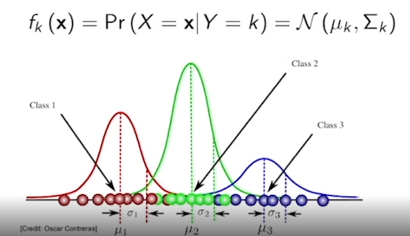
2. 怎麼用 LDA 來做分類？（貝氏定理登場）
既然 LDA 的已知條件是倒過來的（已知類別求資料點的機率），那我們看到一個新資料點 x 時，要怎麼猜它的類別？答案就是用貝氏定理 (Bayes' Theorem) 把機率反轉回來。
貝氏定理的公式長這樣：

當我們要找「哪一個類別的機率最高」時，分母（總和）對每一類來說都是一樣的，所以我們只需要比較分子的大小就好。
文中的數字例子：
比較 5, 7, 3的大小，和比較 5/15, 7/15, 3/15 的大小，最大值都會是中間那一個（也就是 7 或 7/15）。所以分母可以手動忽略！
結論：只要看「高斯分佈機率 x 先驗機率 (f_k(x) ∙ π_k)」誰最大，就把 x 分給那一類。

3. 實例拆解：先驗機率如何改變分類界線
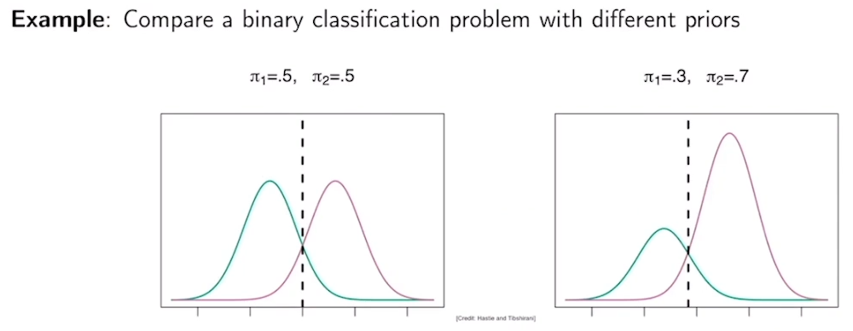
文中使用了一個「二元分類（只有兩類）」的例子，並用兩種類型的先驗機率來做對比：
情況 A：兩類人數平分秋色 (π1 = 0.5, π2 = 0.5)
- 第一類的中心點在 -1.5，第二類的中心點在 1.5，兩邊胖瘦（方差）一樣。
- 因為先驗機率各是 0.5，所以把高斯分佈乘上先驗機率後，兩條曲線高度差不多。
- 她們相交的點（決策邊界）剛好在 0。
- 分類規則： 比 0 小就是第一類，大於等於 0 就是第二類。
情況 B：第二類的人數作弊變多 (π1 = 0.3, π2 = 0.7)
- 這時候，第一類的曲線因為乘上 0.3 變矮了；第二類的曲線因為乘上 0.7 變高了。
- 因為第二類勢力龐大，圖形相交的那個黃金交叉點（Gamma, γ）就會被往左邊推（變成了小於 0 的負數）。
- 分類規則： 門檻往左移了，這代表現在只要資料點稍微靠近左邊一點（但還沒超過 γ），都會因為第二類的先驗機率太高，而被強行歸類為第二類。
💡 總結這段話想告訴你什麼？
- LDA 是一個生成模型，它假設每個類別的資料都符合常態分佈。
- 要用 LDA 做分類，就是去比各類的 「常態分佈機率 x 先驗機率」 誰大。
- 先驗機率非常重要。如果某個類別在現實中發生的機率很高（先驗機率大），分類器的邊界就會「偏心」往另一邊移動，讓更多模糊的地帶都被分到這個大類別去。

▶️ Univariate LDA (9:29)
In the univariate case, when our vector x is one scalar, this is going to be a Gaussian distribution centered at Mu_k, some mean with variance Sigma_k squared, and again, this is the explicit function for that density function. Assuming that we're solving an LDA problem where the variances of all the classes are identical to each other, then we can do the following operations. Remember that the optimal classifier is going to assign a label k to an input x according to this maximization. Also notice that if you want to find the maximum in a sequence of positive values, you can also find the maximum by looking at the log transformation of those values. For example, if your values are 5, 7 and 3, if you compute the log of 5, the log of 7, and the log of 3, the index that reaches the maximum value in the sequence above is going to be the same index that reaches the maximum value in the sequence below. This is obvious if you look at the log function because this is a monotonically increasing function. Also notice that after applying the log transformation to the product of Pi_k times the Gaussian density, we're going to have this term in here and applying some simple manipulations, including a logarithmic transformation of this exponential, one can prove that the optimal index in the maximization above is equal to the optimal index of the maximization of these functions in here. Notice that these functions depend linearly on x. In other words, this term in here is nothing but a constant that does not depend on x, and this term in here is a coefficient multiplying the x. So everything inside these parentheses is a linear function of x, which is computationally very convenient. We are going to define the expression of x inside this parentheses as Delta_k of x, so we can write this last equality. To wrap up this slide, I would like to mention that in practice, we're not explicitly given the values of the mean, the variance and the priors that nature is using to generate the data set. In other words, these values are only known by nature that for us is a black box from where we retrieve data. Naturally, this take us to our next point, which is how can we estimate the parameters Mu, Sigma, and Pi_k from a given data set. To solve this issue, we can use these expressions. In the first expression, we can estimate the prior of the class k using the fraction N_k over N, where N_k is the number of samples in the class k. We can also estimate the mean of class k by considering all the points x whose output is equal to the class k. By performing a simple averaging, we will obtain an estimate of the mean for k. The common variance in our problem can be computed using this expression, where k is the total number of classes in our problem and Mu hat are computed in the expression above. This expression can also be rewritten as the expression in the bottom, where Sigma hat of k squared is defined in this last expression at the bottom. Let's now illustrate LDA with a numerical example. We're going to assume two priors equal to one-half and two Gaussians, one centered at minus 1.5, the second one centered at 1.5, and both Gaussians have the same variance equal to one. In the plot of the left, will show you the plots for Pi_1 f_1 of x and Pi_ f_2 of x.Therefore, according to the rules of nature, we will read the classifier that assigns a label 1 for x less than zero, and assigns a label 2 for x greater or equal than zero. However, in practice, we do not have explicit access to the function Pi_1 and f_1. What we have access to is a data set of samples taken from these distributions. For example, roughly half the points will be sampled for the green Gaussian. So if we sample a collection of points from the green Gaussian, they will be mainly centered around the values in which this Gaussian takes a high value. We will also have roughly 50 percent of our points sampled from the second pink Gaussian, and these points will be somehow concentrated around the mean of the second Gaussian. The resulting collection of points is our data set D, and this is the only information that we have to find the Optimal Bayesian Classifier. In the picture on the right, you can find histograms of the green points and the pink points in the figure on the left. Also, we have two vertical lines; the dashed vertical line correspond to the threshold value of the classifier that we would build if we knew the parameters that nature is using to generate the data. However, using our data set, we will have estimates for Mu_1, Mu_2, Pi_1, Pi_2, and Sigma squared that we can then use to find a new threshold value represented in the solid vertical line. Therefore, our estimate of the Optimal Bayesian Classifier will not classify points being less or equal than zero, but according to some value Gamma that will be slightly less than zero.
Let's move on now to the case when p is greater than one. In this case, the Gaussian density takes a slightly more convoluted form describing this equation. Remember that this function is going to be the probability that x is equal to some value x given that y is equal to k, and this value x is in boldface. This function is going to be a multivariate normal distribution centered at Mu_k, a given mean, and a covariance matrix Sigma, which we are going to assume for simplicity, is identical for all classes. So notice that both x and Mu_k are p-dimensional vectors, and Sigma_k, which in this case is going to be equal to Sigma, is a p by p matrix. We can look both into a theoretical and numerical example of a multivariate LDA. In the left, we get a theoretical example where Pi_1 time f_1 of x is represented by a Gaussian whose level set is given by the orange ellipsoid, Pi_2 times f_2 is a two-dimensional Gaussian where the level set is equal to the green ellipsoid, and Pi_3 times f_3 is a Gaussian whose level set is a blue ellipsoid. If you're not familiar with level sets, essentially what the level set of the Gaussian in this figure is, is nothing but the ellipsoid that results from cutting this Gaussian used in a horizontal plane. So if you take a horizontal plane and cut this Gaussian in the middle, you will get an ellipsoid in here. If you look at this ellipsoid from above, you will get the figures in this plot. So in here we have three Gaussians. The Gaussian for the first class is centered in here, so this could be Mu_1, the Gaussian for the second class will be centered in here, so this is going to be Mu_2, and the Gaussian for the third class is centered around here. So now notice that Mu_1, Mu _2, and Mu_3 are two-dimensional vectors. That's why we plotted as points on a plane. The dashed lines are the results of applying the rules of the Bayes Optimal Classifier to this theoretical densities. So you can notice that any point in this region will be classified as class 1, any point in this region will be classified as class 2, and any point in this region will be classified as 3. Notice again, that these points are points on a plane, meaning points with two entries. Again, in practice, we would have access to the means, the covariance, and the prior probabilities, and we have to estimate these values from a data set. This data set is plot in the right figure, essentially the orange, green, and blue points. Using this collection of points, we can get estimates of the unknown parameters that nature is using to generate the data, and we would get a slightly different boundaries for our estimate of the Bayes Optimal Classifier.

線性判別分析（LDA）最核心的數學推導、參數估計，以及如何從一維（Univariate）延伸到多維（Multivariate）空間。
階段一：一維 LDA 的數學魔術（為什麼叫「線性」？）
在只有一個特徵（x 是純量）且假設所有類別的方差（Variance, sigma^2）都相等的情況下，公式可以大幅簡化：
1. 為什麼要取 Log（對數化）？
上一段說過，我們要找讓 π_k ∙ f_k(x) 最大化的類別 k
因為高斯分佈的公式裡有討厭的指數（e 的次方），數學上為了好計算，會對整體取 Log。
文中的數字例子：
比較 5, 7, 3 的大小，跟比較 ln(5), ln(7), ln(3) 的大小，最大值的索引（Index）完全不會變。因為 Log 是一個單調遞增函數（Monotonically Increasing Function）。
2. 化簡後的驚人發現：線性函數 δ_{k}(x)
當我們把高斯分佈公式代入並取 Log 後，神奇的事情發生了：那些複雜的平方項和常數項，在經過一陣消去後，最終留下來決定勝負的公式（我們稱為判別函數 δ_{k}(x)）長這樣：
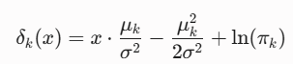
-x²/(2σ²)：因為每個類別的 σ 都相同，對於同一個輸入點 x 來說，這一項在每個類別算出來的值完全一模一樣，刪掉！
Ln(1/(2^{0.5} σ)：因為每個類別的 σ 都相同，這項是常數，大家都有，刪掉！
你會發現 x 的次方只有 1 次方！
- 它是一個線性函數（Ax + B 的形式）。
- 這就是為什麼這個方法叫做「線性」判別分析（LDA），在計算上非常快速、方便。
- 如果不假設方差相等（也就是保留 σ_{k}²），那麼 -x²/(2σ²)這一項就會因為每個類別的 σ_{k}不同而無法被消去！判別函數裡保留 x²的二次項，分類的邊界就會變成拋物線、雙曲線等曲線。這就是 QDA（二次判別分析, Quadratic Discriminant Analysis）。

階段二：理想 vs. 現實（如何從數據估計參數？）
影片提到一個重要觀念：「大自然（Nature）知道真正的參數，但我們不知道。」 我們手上只有一堆數據（Data set D），必須用數據去「猜」（估計）大自然的參數：
- 猜先驗機率 (hat{π_{k}})： 用「第 k 類樣本數（N_{k}） 除以 總樣本數（N）」。
- 猜平均值 (hat{µ_{k} })： 把所有屬於第 k 類的資料點加起來算平均。
- 猜共同方差 (hat{σ²})： 計算各類別內部資料點到該類平均值的距離平方和，再做加權平均（變相的混和方差）。
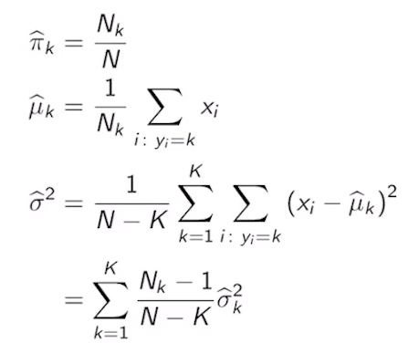
- 簡單來說，σ^2分母除以 N - K（而不是總樣本數 N），是為了要進行自由度校正（Degrees of Freedom Correction），以確保我們計算出來的共同方差（Pooled Variance）是不偏估計量（Unbiased Estimator）。如果直接除以 N，我們算出來的方差在統計上會「系統性地偏小」（也就是有偏誤）。

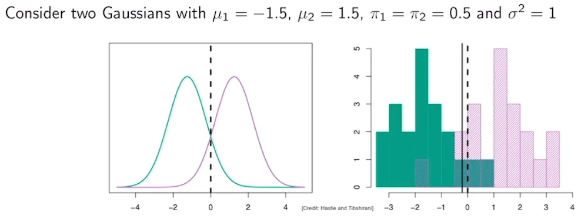
數據帶來的誤差（圖表解讀）
- 理論上的完美國度（左圖）： 如果知道大自然的真實參數，分類界線（Dashed Line）剛好在 0
- 現實的數據世界（右圖）： 我們抽樣出來的數據會有統計隨機性。利用右圖的直方圖（Histogram）算出來的平均值和方差，推導出來的實質分類界線（Solid Line）會稍微偏離 0，變成一個接近 0 的數值 γ。這就是估計帶來的誤差。
階段三：進階到多維空間（p > 1）
當特徵不只一個（例如預測身高＋體重，x 變成一個向量）時，高斯分佈就變成了多變量常態分佈（Multivariate Normal Distribution）。
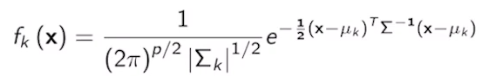
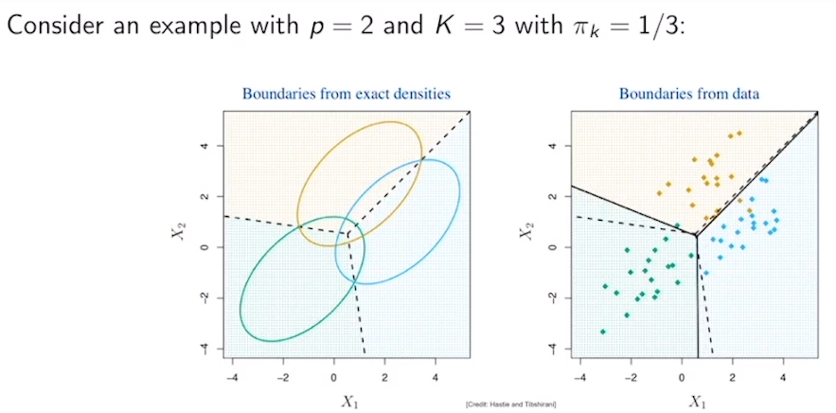

1. 什麼是等高線/水平集（Level Sets）？
在二維平面上，多維高斯分佈看起來就像一座 3D 的山。
- 文中所說的 「水平集（Level Set）」，就是你用一個水平的刀子把這座山橫著切開。
- 切開後的切面，從正上方看下去，就會形成一個個橢圓形（Ellipsoid）。
- 因為 LDA 假設所有類別的協方差矩陣（Covariance Matrix, Σ）都相同，所以你會發現圖中三個類別（橘、綠、藍）的橢圓形胖瘦、傾斜方向完全一模一樣。
2. 多維空間中的分類界線
- 在理論上（已知真實參數），這三個類別的交界線（虛線）是幾條直線（在更高維度就是超平面），將平面完美切成三塊區域。
- 在現實中（右圖的散點圖），我們同樣只能利用這些彩色的數據點去估計三座山的中心（µ_{1 ,} µ_{2 ,} µ₃）和共同的形狀（Σ），最後畫出稍微有一點偏差的實線分類界線。
💡 總結核心重點
- LDA 為什麼是線性的？ 因為在假設「各類別方差相等」的前提下，取對數（Log）後的判別公式是一條直線。
- 現實中怎麼做？ 我們用樣本的頻率算先驗機率，用樣本平均數算 µ，並算出一組共享的方差。
- 多維空間的視覺化： 多維 LDA 的類別分佈是傾斜方向相同的橢圓形，而它們之間的防線（決策邊界），依然是直的（線性的）。

1 Attempt Quiz: Univariate LDA

2. Error Measurements in LDA
▶️ Classification Errors (7:10)
In the previous video, we saw how to use linear discriminant analysis to solve classification problems. In this video, we're going to analyze classification errors. We are going to study this problem considering the classification problem with the following ingredients. We're going have two classes that we denote by C (0,1) so essentially is a binary classification problem. We're going to consider a training data set of p-dimensional input vectors and a scalar outputs, and this a scalar will be either zero or one, and the classifier function C that takes as input have p-dimensional vector and the output it generates it's either zero or one. When we classify a particular input, the output of the classifier can be categorized as follows. If the output of the classifier is the same as the actual label and this label is one, we say that this point i is a true positive. If the output of the classifier is, again, equal to the actual output and this value is equal to zero, then we say that point i is a true negative. In contrast, if the output of the classifier is one, but the actual output of that point is zero, then we are making a mistake in the classification, and we say that point i is a false positive, which is our first type of mistakes in our classification. We also have another type of mistakes which happened when the classifier generates a zero for a given input x_i, but the actual output associated to that input is one. In that case, the error is called a false negative. So you can think of these errors when classifying, for example, cancer biopsies. You can take a collection of medical measurements about the tissue from a patient in order to classify if this tissue is cancerous or not, and this classifier can generate either a positive test indicating that according to the classification method, the tissue is cancerous or could be negative indicating that according to the classification method, this tissue is not cancerous. However, you can make mistakes in your classification method. Essentially, your classifier could say that a tissue is cancerous when in reality is not, and vice versa. So it's important that we analyze the cost of each type of mistakes. The total number of errors made by a classifier is equal to the sum of false positives and false negatives. We can define formally false positives and false negatives using the equations below. So essentially, the total number of false positives that our classifier makes in a given data set is given by the formula on the right. In this formula, we're going to have a summation over all data points of an expression that seems a bit mysterious, but I will break it down for you. Essentially, this function delta, this is a function called a Dirac's delta function. This is a function that takes a value of one only when the argument of this function is zero. When the argument is different than zero, the output of the function is equal to zero. So graphically, what this function looks like for x equal to zero, it's going to be a function that takes a value one, and when the x is different than zero, the function is equal to zero. So it's essentially a spike centered at zero. Now, going back to this equation, notice that we're summing the product of two Dirac deltas. These Dirac functions as either zero or one, and their product will be one only when both Dirac deltas generate a one. In this case, the first delta will generate a one when the argument inside the parentheses is equal to zero, which happens when C of x_i is equal to one. The second direct delta will generate a one whenever y_i. So you can see that these two conditions had the definition of i being a false positive. If you make a summation over all indices, you will get the total number of false positives. We can follow the similar logic to count the total number of false negatives. In that case, this delta will be one whenever C x_i is equal to zero, and the second delta will be one whenever y_ i is equal to one. Notice that these two conditions are satisfied for false negatives, and when you count over all possible indexes, you will obtain the total number of false negatives. Using these two expressions, we can define the classification error rate, which is nothing but the total number of errors, which is the sum of the number of false positives plus false negatives, divided by the total number of points. We now present an appealing theoretical analysis of classification errors in the case of Linear Discriminant Analysis. We're going to consider an LDA with one input, meaning Pi is equal to one, and two classes, meaning the output labeled as either zero and one. The ingredients of LDA are the two priors, Pi_0 and Pi_1, as well as the functions F x_k, which represent the conditional probabilities of x being equal to x when y is a particular label k. This k, remember, can take the value either zero or one. When we're given these ingredients, we can compute the expected classification error for that base optimal classifier. Notice that in practice, you will compute the classification error using a particular data set and your result will be numerical. But whenever we are given the theoretical ingredients, we can actually perform a theoretical study to compute the expectation of the classification error. So first of all, remember that the base optimal classifier in the case of LDA is a classifier defined below. We will have an output zero whenever Pi_0 times F_0 is greater than Pi_1 times F_1, and this will result in a condition x less than gamma, where gamma is this crossing point in the figure below. The output will be one when by Pi_1 F_1 is greater or equal than Pi _0 F_0, and this will happen for x greater or equal than gamma. So in particular, the classifier will generate a value zero here, and we'll generate a value one here.

機器學習中非常核心的觀念：分類錯誤分析 (Classification Error Analysis)。
前半段主要利用常見的混淆矩陣 (Confusion Matrix) 概念來定義錯誤；後半段則將這些錯誤延伸到 LDA 的理論分析。
1. 醫療檢測最愛的四個象限（混淆矩陣）
影片用「癌症組織切片（Biopsy）」當作例子。當我們用一個分類器 C 去預測病人的組織是癌症（1）還是正常（0）時，會產生四種結果：
預測值 (Classifier) \ 真實值 (Actual) | 癌症 (Y=1) | 正常 (Y=0)
預測為癌症 (C(x)=1) | 真陽性 (True Positive, TP)  正確抓出癌症 | 偽陽性 (False Positive, FP)  沒病被說有病（type1 error）
預測為正常 (C(x)=0) | 偽陰性 (False Negative, FN)  有病沒抓出來（type2 error） | 真陰性 (True Negative, TN)  健康且預測正確
代價的思考：
影片特別提到「必須分析每一種錯誤的代價」。在醫療上，偽陰性 (FN) 的代價通常極高（因為代表病人有癌症卻沒被檢查出來，延誤治療）；而偽陽性 (FP) 則是虛驚一場，需要進一步做切片確認。

2. 拆解神祕的計數公式：狄拉克 δ 函數
一個看起來很炫的公式來計算總偽陽性人數 (Total FP)，公式長這樣：
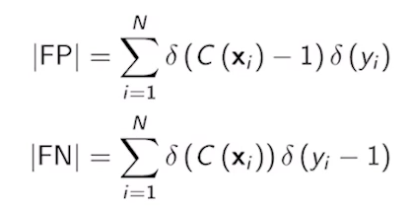

講者特別解釋了這裡的 δ (Dirac delta function) 是當作「離散的指標函數（Indicator Function）」來用。它的運作規則只有一條：
- 只有當括號裡面的數字是 0 的時候，δ的輸出才是 1
- 只要括號裡不是 0，輸出就是 0
為什麼這能用來算偽陽性 (FP)？
我們要讓後面相乘的兩顆 δ 同時吐出 1，乘起來才會是 1（只要其中一個不符合，乘起來就是 0）：
- 第一顆 delta(C(xi) - 1) = 1： 必須滿足 C(xi) - 1 = 0，也就是模型預測 C(xi) = 1
- 第二顆 delta(yi - 0) = 1： 必須滿足 yi - 0 = 0，也就是真實標籤 yi = 0
這兩個條件同時成立時，不就剛好符合「模型說你是癌症（1），但你其實很健康（0）」的偽陽性 (FP) 定義嗎？把所有資料點 i 的結果加總起來，就是總錯誤人數。
同理，偽陰性 (FN) 的公式
最後，分類錯誤率 (Classification Error Rate) 就是把這兩種錯誤加起來，除以總人數 N：
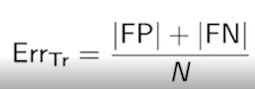

3. LDA 的理論錯誤率分析（預告）
一維的 LDA 機率模型（特徵 p=1，類別為 0 與 1）。
在理想的理論世界中，大自然給了我們：
- 先驗機率：π0 和 π1
- 高斯分佈：F0(x) 和 F1(x)
貝氏最佳分類器畫出了一條生死線（決策邊界 γ）：
- 當 x < γ 時，模型預測為類別 0
- 當 x ≥ γ時，模型預測為類別 1

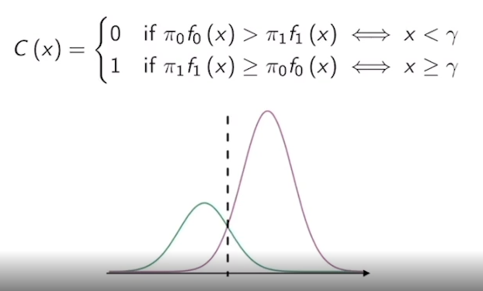

因為我們知道這兩條高斯曲線在理論上的完整形狀，我們接下來就不用依賴現實中髒髒的數據點去數人頭了，而是可以直接透過計算曲線底下的積分面積（期望值），在數學上直接推導出這個分類器注定會犯下多少的理論錯誤率。
💡 學習小結
這段影片是個轉折點，它從「教你怎麼建立 LDA 分類器」，變成「教你怎麼評估這個分類器好不好」。它建立了分類錯誤的標準術語（TP, TN, FP, FN），並預告了下一步要如何從幾何圖形（高斯曲線交界）去計算理論上的期望錯誤率。

▶️ Confusion Matrix (8:29)
For any classifier, we can build what's called a confusion matrix which is a table that somehow represents the different types of errors that our classifier can commit. So in this table, we're going to consider points i for which the actual output is zero, points i for which the actual output is one, as well as points i for which the input x_i, passing through the classifier, predicts an output 0 or predicts an output 1. In the middle part of this table, we see a two-by-two matrix. In this matrix, we include several numbers. In the first entry, we're going to include the total number of true negatives, which correspond to points for which our classifier predicts a negative value and the output is in fact negative. We also have the true positive entry, which correspond to points for which the classifier predicts an output 1 and the point actually have an output 1. We also have two error terms. The first one is the false positive error term, which corresponds to points for which the classifier predicts a one even though the actual output is a zero. Similarly, we have the false negative entry that correspond to points for which our classifier predicts a zero even though the actual output is one. At the bottom of the table, we include the summation of the two terms in this column. In the second entry, we include the summation of the two terms in that column. We can also perform summations horizontally so if we sum these two terms, we'll obtain the summation on the right. If we sum these two terms, we will get the summation on the right. If we sum all the entries, we will get N. So this is essentially how the confusion matrix is build. Let's look into the confusion matrix of a particular example. In this example, we're going to consider an LDA classifier and we're going to use the default data set containing individuals that ask for credit to a bank and some of them default on their credit. For this particular data set, the confusion matrix takes the following form. So we're going to start on the bottom entry. Essentially we have 10,000 individuals in our data set. This entry is telling us that the number of individuals that did not default, in other words that were able to pay back the money they owe to the bank, had equaled to 9,667. This entry in here tells us that the number of individuals that defaulted on the credit were 333. Looking at the entries in the inner part of the confusion matrix, we see that our classifier is able to correctly classify 9,644 individuals as people that will pay back their dues and they in fact paid back. However, the LDA classifier predicted that 23 individuals would not be able to pay back their dues, although they were able to pay. So in this situation, the classifier is hurting some people that could pay back, but the classifier decides that they're unlikely to pay you back. In the second column, we have that our classifier was able to correctly identify 81 people that were not able to pay and the classifier was able to predict that fact. However the classifier failed to identify 252 individuals that were not able to pay back, but the classifier decided that they were worthy of a credit line. In other words, the bank lent them money based on the classifier and this 252 individuals did not pay back. Based on these numbers, the classification error rates are equal to these two of diagonal elements, meaning the false positives and the false negatives that are included in the numerator, and the total number of points, 10,000 in the denominator. Therefore the classification error rate is 2.75. Now, is this a good classification rate? Well, we can compare this classification rate with something that's called a null classifier. So this is a classifier that assign an output 0 to every single input. In other words, the classifier will allow the bank to lend money to every single person that is asking for money. In this particular case, the two elements in this entries of the confusion matrix will be equal to 0 because we will never classify inputs as being equal to 1. Therefore, the 9,667 individuals in the category y equal to 0 will all be included in this entry and the 333 people that did not pay back their dues will be included in this entry. So this entry will be 333. This entry will be 9,667 for the null classifier. Now we can recompute the classification error rate for the null classifier, which is going to be equal to 333 divided by 10,000 which results in a rate of 3.33 percent. So you can see that this is not too far from the error rate obtained from an optimal Bayesian classifier. Now let's move on to some observations on the LDA classifier. The first observation is that for the set of samples for which y is equal to 0, we made an error rate of 23 out of 9,667. Essentially going back to the table, this is nothing but the ratio between this number and that number. Also, for those samples for which y_i is equal to 1, the error rate was 252 divided by 333. Going back to the table, this is nothing but the total number of errors that we make for this class of individuals divided by the total number of individuals, which is 333. The first fraction provide a result of 0.2 percent probability, and the second fraction give us an error rate of 75 percent. What this number is telling us is that out of the pool of people in our data set that we're not able to pay back their credit to the bank, the classifier was only able to catch roughly 25 percent of those cases. So this is not a very good performance if you think about and for that reason, the classification error rate alone typically is not a good measure of performance. To refine our measures of performance, we're going to define other classification rates. So we're going to define the true positive rate as the fraction between the number of true positives divided by the sum of true positives plus false negatives. Let me write down in here the confusion matrix and fill in with the values that we defined above. So according to this table, the true positive rate is nothing but the ratio between the number of true positives over the total number of points for which y is equal to 1. Similarly, we can define the true negative rate as the fraction of the total number of true negatives divided by the total number of points for which y is equal to 0. Furthermore, the false positive rate is going to be equal to FP divided by the same number that we had before, meaning the total number of individuals for which y is equal to 0. The false negative rate is the ratio between FN and the total number of points for which y is equal to 1. Notice that the false positive rate can easily be written as 1 minus the true negative rate and the false negative rate can be written as 1 minus the TPR, the true positive rate.

1 Attempt Quiz: Classification Errors

機器學習在真實商業世界（金融貸款）的經典案例，並點出了一個非常震撼、所有初學者都該記住的觀念：「高準確率（低錯誤率）不等於模型很好！」
我為你將這段極具實戰價值的內容拆解為三個核心部分：
1. 銀行信用風險案例（混淆矩陣實戰）
影片使用了一個 10,000 人的銀行貸款數據集，分類目標是預測客戶是否會違約（Default, Y=1）：
真實數據矩陣：
- 總人數 (N)：10,000 人
- 實際上沒違約（Y=0）：9,667 人
- 實際上違約了（Y=1）：333 人（佔總數約 3.33%）
LDA 分類器的預測結果：
- 真陰性 (TN) = 9,644：預測不會違約，實際上也乖乖還錢。
- 偽陽性 (FP) = 23：模型覺得他們會違約，但人家其實會還錢（銀行錯失客戶）。
- 真陽性 (TP) = 81：成功抓到會違約的壞帳客戶。
- 偽陰性 (FN) = 252：模型覺得他們是好人，結果一借錢出去就違約不還（銀行慘賠）。
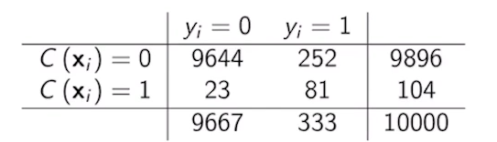

整體錯誤率計算：
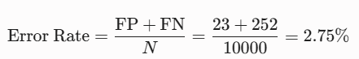
看外表，這個模型高達 97.25% 的準確率（100% - 2.75%），看起來無懈可擊，對吧？

2. 殘酷的現實：「虛無分類器」的世紀大嘲諷
為了檢驗 2.75% 的錯誤率到底有多厲害，影片引進了 虛無分類器 (Null Classifier / Baseline)。
什麼是虛無分類器？
它是一個完全「不帶大腦」的模型。在貸款場景下，它假設「每個人都是好人，每個人都放款」（全部預測 C(x)=0）。
如果銀行用這個無腦模型，結果會怎樣？
- 9,667 個好人全部拿到貸款（TN = 9,667，FP = 0）。
- 333 個壞人也全部拿到貸款（FN = 333，TP = 0）。
- 無腦模型的錯誤率 = 333/10000 = 3.3%
發現了嗎？
高端的 LDA 模型大費周章算了一堆高斯分佈，錯誤率是 2.75%；而路邊盲猜的無腦模型，錯誤率是 3.33%。兩者只差了 0.58%！
更慘的是，如果看針對違約者 (Y=1) 的捕捉能力：
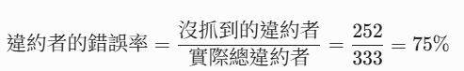
這代表高達 75% 真正會倒帳的壞人，LDA 分類器完全抓不到！ 它的破案率（Sensitivity）只有 25% (81/333)。這在金融風控上是絕對無法接受的災難。
這就是為什麼影片說：在數據不平衡（Imbalanced Data）時，單看整體錯誤率或準確率是個巨大的陷阱。
3. 進階評估指標：看穿模型的照妖鏡
為了不被漂亮的整體錯誤率欺騙，我們必須把各個象限拆開來看，因而衍生出了以下四個核心進階指標：
1. 真陽性率 (True Positive Rate, TPR)
又稱敏感度 (Sensitivity) 或 召回率 (Recall)。
- 定義： 在所有真正違約的人當中，模型成功抓到多少人？
- 公式：
2. 真陰性率 (True Negative Rate, TNR)
又稱特異度 (Specificity)。
- 定義： 在所有正常還錢的人當中，模型正確認出多少人？
- 公式： 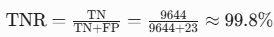
3. 偽陽性率 (False Positive Rate, FPR)
- 定義： 正常人被誤判為違約的機率（冤枉好人的機率）。
- 公式： 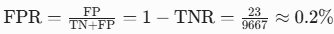
4. 偽陰性率 (False Negative Rate, FNR)
- 定義： 違約者被漏抓的機率（放過壞人的機率）。
- 公式： 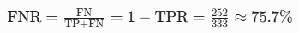
💡 總結這段的核心精髓
當資料中「某一種類別極少（例如 10,000 人中只有 333 人違約）」時，模型只要全部猜多數的那一類，就能輕鬆刷出漂亮的準確率。
這段內容正是要告訴我們：評估模型必須看 TPR 與 FPR 的拉鋸。 下一段影片通常會教你如何透過調整「決策門檻（Threshold）」，把那個高達 75% 的漏網之魚（FNR）壓下來。

▶️ Errors in LDA (5:29)
In LDA, if we have explicit information about the prior and conditional probabilities, we can compute explicit expressions for the expected values of false positives and false negatives. To compute the expected value of false positives in LDA, we can simply apply the expected operator on the definition that we saw before and include the expectation inside the summation, since expectation is a linear operator. Notice that the function inside the bracket is nothing but the function that we use to count false positives in our previous slides. This function is nothing but a function with two arguments, X and Y, and we need to compute the expectation of X and Y which I have explicitly indicated in the expectation. Now, to go into the second equation, we need to apply the law of total expectation. To refresh your memory, this law states the following, if we want to compute the expectation of a function of X and Y, where X is a continuous variable and Y is a discrete variable, which is our case, this can be written as, a summation when a small y takes any value in the possible set of Ys of the expectation of g of X, Y, given that Y takes a particular value, small y, times the probability that Y is equal to a small y. Using this equality, we know that these are our priors and these are nothing but conditional expectations that we're degrading here. In that particular case, this set y is equal to zero and one. This summation we break down into two terms. This first term, which correspond to the case of small y equal to zero and the second case, which corresponds to the case of a small y equal to one. Notice also that these probabilities become the priors, Pi_0 and Pi_1. After we evaluate the value of y equal to zero in the first equation, notice that we will condition for y equal to zero and this term in here will become one in the first term. However, when y is equal to one, the second Delta will become zero and will cancel everything inside the bracket. At the end of the day, this whole term will be canceled in our summation. To move on to the next line, we're going to apply the definition of the conditional expectation, essentially we are going to do the integral for any value of X of the function for which we want to compute the conditional expectation times the conditional density evaluated at a particular value of Y under consideration and we will integrate our X. This is nothing but a particular application of the conditional expectation that we saw in the probability review videos. Now, notice that Pi_0 is a constant that can move on to the next slide. F of X given Y is nothing but the function f_0 of X, and this function, Delta of C x minus 1, is going to be equal to 1 when C x is equal to 1, according to the Bayes optimal classifier. Notice that the integral term is independent of i. If we perform the summation of N terms that are identical, we will get N of those. We will multiply by N to take into account the summation. At the end of the day, we get a clean expression, representing the expected value of false positives in an LDA classifier. Similarly, we can compute the expected number of false negatives by performing the integration at the end of the slide. These two integrals have a very appealing graphical interpretation. Looking into the expression for the expected value of false positives, we see that we are going to have to integrate the function, Pi_0 f_0, when x is greater or equal than Gamma. Remember that the function, Pi_0 f_0, is given by this bell and Gamma is the crossing point in here. Therefore, the integral is nothing but the area under this function that I'm going to represent in red. This red area times N will give us the expected value of false positives. We have now a similar interpretation for the expected value of false negatives. In here, the integral is going to be on the compliment set, meaning x less than Gamma, and the function we need to integrate is Pi_1 one which as you may remember, is this function in here. Therefore, the area related to false negatives is going to be the area under the pink curve in this particular regime, which is this shaded area in here. By multiplying this area times N, we will get an expected value of false negatives.

1 Attempt Quiz: Errors in LDA

進入了 LDA 錯誤率分析的最高潮——如何用嚴謹的機率與微積分（數學期望值），直接推導出模型「注定會犯多少錯誤」。
影片的前半段是用數學公式進行抽象推導，後半段則是將這些積分公式轉化為極其直觀的圖形面積。
步驟一：用「全期望值定理」拆解神祕公式
我們想知道在理論上，這個 LDA 分類器預測的偽陽性人數期望值（Expected False Positives）是多少。
根據前面學到的狄拉克 δ 計數公式，加上期望值具備「線性特質」（可以把期望值符號 E 丟進加總 Σ 裡面），公式起頭長這樣：
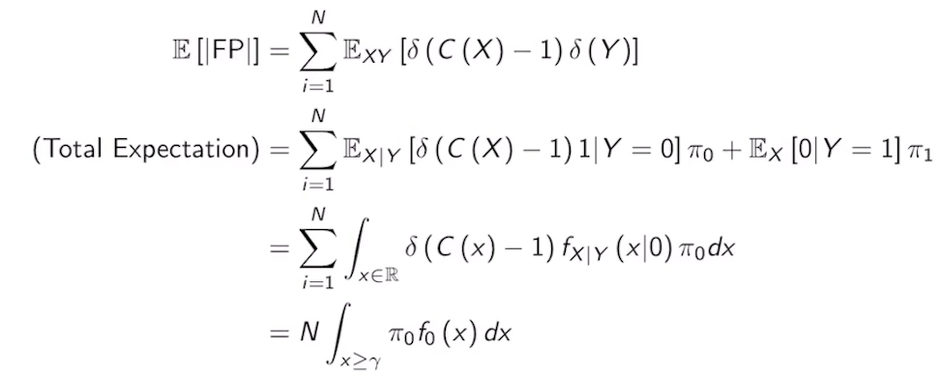
因為這裡包含兩個隨機變數：連續的特徵 X 和離散的標籤 Y。講者引進了全期望值定理 (Law of Total Expectation)。這個定理說，如果要算 E[g(X, Y)]，可以先固定 Y 的條件，算完再乘以 Y 的機率加總。
因為 Y 只有 0 和 1 兩種可能，所以公式會被拆成兩項：
- 第一項（當 Y=0）：
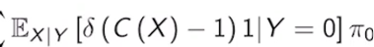
- 第二項（當 Y=1）：
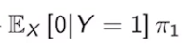
關鍵的死穴：第二項直接變 0！
注意到公式裡有一項是 δ(yi - 0)
- 在第一項中，因為條件是 Y=0，所以 δ(0 - 0) = 1，這項安全留下來。
- 在第二項中，因為條件是 Y=1，所以 δ(1 - 0) = δ(1) = 0！這導致第二項直接從宇宙中消失。
因此，公式瞬間被精簡到只剩下一半，而 P(Y=0) 就是我們的先驗機率 π0
步驟二：從期望值跨入微積分的「連續積分」
既然條件已經固定在 Y=0，接下來要對連續變數 X 算期望值。根據連續隨機變數的定義，算期望值就是把「目標函數 x 條件機率密度函數 f0(x)」拿去做全空間的積分：
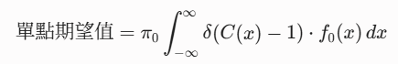
此時，前面的 δ(C(x) – 1) 再次發揮篩選功能：
- 只有當 C(x) = 1（模型預測為類別 1）的時候，它才等於 1。
- 根據 LDA 的決策邊界，什麼時候模型會預測為 1 呢？就是當 x ≥ γ 的時候。
所以，這個 delta 函數的實質效果，就是把積分範圍從「負無窮到正無窮」，限縮到「γ 到正無窮」！在該範圍內 delta 值為 1，其餘地方為 0。
因為每個資料點 i 的分佈都一模一樣（獨立同分佈），總共有 N 個點，加總起來就是直接乘以 N。我們得到了最終極為乾淨的理論預測公式：
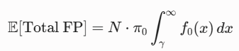
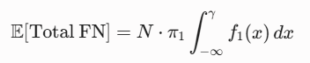

步驟三：完美的幾何圖形解讀（看圖秒懂）
這兩個積分公式在統計圖學上有著非常漂亮的含意。請想像兩條高斯鐘形曲線（一條是類別 0 的 π0 f0，一條是類別 1 的 π1 f1），它們交會在那條生死線 γ：
1. 偽陽性的期望值（圖中的紅色面積）
- 公式要我們積分 π0 f0（類別 0 的曲線），範圍是從 γ 到右側的正無窮。
- 幾何意義： 這些人本質上是類別 0（屬於左邊那座山），但因為他們的特徵值 x 太偏右了，越過了邊界 γ，導致模型誤判他們為類別 1。這塊在邊界右側、由類別 0 曲線所圍出來的尾巴面積（乘以 N），就是偽陽性的人數。
2. 偽陰性的期望值（圖中的陰影/粉色面積）
- 公式要我們積分 π1 f1（類別 1 的曲線），範圍是從負無窮到左側的 γ
- 幾何意義： 這些人本質上是類別 1（屬於右邊那座山），但因為特徵值 x 太偏左，落在了邊界 γ 的左邊，導致模型誤判他們為類別 0。這塊在邊界左側、由類別 1 曲線圍出來的尾巴面積（乘以 N），就是偽陰性的人數。
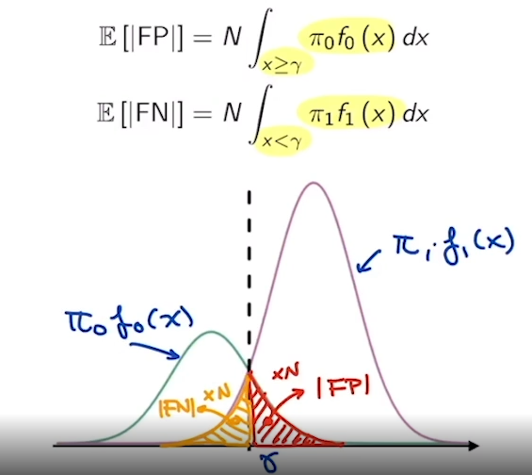
💡 總結這段的核心結論
這段影片展現了數學預測的威力：只要給定大自然的真實參數（先驗機率與常態分佈），不論你實際上到底有沒有去抽樣數據，你都能透過計算這兩塊「越界尾巴的面積」，精確預知這個分類器未來的理論錯誤率是多少。
這也是為什麼科學家在設計分類器時，可以透過上下移動 γ（調整門檻）來人為控制這兩塊面積消長的原因。

▶️ ROC (11:28)
After introducing these definitions, we move on to the question, how do we choose a classifier? So to choose a classifier in practice, you should take into account the cost of false positives versus the cost of false negatives. For example, if you're a medical doctor, the cost of committing that false-positive is not the same as the cost of committing a false negative. For example, if you tell a person that he or she doesn't have cancer, when in fact he or she has cancer, the cost is much higher than if you tell somebody that he or she does have cancer when the case is that she or he doesn't have cancer. In the first case, this person can go along thinking that he doesn't have cancer when in fact he does. In the second case, you will just make more tests to verify that there is a cancer there, and at the end there is no cancer, that could be good news for the patient. Similar story when you're dealing with a bank. There is a different cost in deciding that a person does not deserve credit when this person in fact deserve credit, to the case when you think that the person deserves credit, but the person will not pay you back. So in the second case, the cost for the bank is much higher. In the first case, the cost is mainly the financing cost of the individual. With this observation in mind, we will describe below a way in which we can balance these costs. But first remember that a Bayesian classifier satisfies the following equation. In particular, the output of the classifier will be one when the probability of y given x is greater than or equal than one-half. This is valid for the binary case because the probability of y equal 1 given X equal to small x, plus the probability of Y equals 0 given X is equal to small x have to sum to one. Therefore, this probability will be larger that the second probability when this value is greater or equal than one-half, and this is what we have in this condition. On the other hand, the classifier will produce a zero whenever the probability of Y equals one given x is less than one half. Also, it's important to remark that this classifier minimizes the total classification error rate. Therefore, the classifier is cost optimal when the cost of false positives and false negatives are the same. To consider problems in which these costs are different, we're going to define a different classifier parameterized by a threshold Tau. So this value of Tau will be a number between zero and one, and the output of this classifier will be formally very similar than the one using the Bayesian classifier, but we will change the value one-half use at the end of this expression to a value of Tau. By changing this value of Tau, we will be able to trade off the cost of false positives and false negatives.
To illustrate this point, let's look at how the false negative rate and the false positive rate of this new classifier change as a function of Tau. In this particular illustration, we will use data from the default dataset. So based on the definition that we had in the previous slide, our threshold classifier will produce a one when this conditional probability is greater or equal than Tau. But according to Bayes Theorem, this conditional probability can be written using this expression. So assuming that we have access to the priors and to the conditional probabilities, we will be able to explicitly compute all the error rates for different values of Tau. In the figure below, we compute the different error rates when Tau changes from zero to one-half. Notice that when Tau is equal to 0, the probability of y equal to 1 when x is equal to x will always satisfy that is greater than or equal than 0. Therefore, all the points in the dataset will be classified as one. Nobody will be classified as a zero. Therefore, we won't have room to make false negative errors. That's why the false-negative error rate represented in this blue plot is zero when tau is equal to zero. In contrast, the false positive rate defined as the ratio between false positives and all the cases for which the actual output is equal to zero will be equal to 9,667 individuals divided by that same number plus zero. Because nobody will be a true negative if everybody is classified as positive. In other words, the orange plot representing the FPI will bike to one at the value Tau equals zero. Also notice that as we increase Tau, the false-negative rate will increase monotonically, while the false positive rate will decrease monotonically. For tau equal to one-half, we obtain the rates of the base classifier. Since Tau equal to one half is exactly the definition of the base optimal classifier. Remember that those rates were 0.2 for the false positive rate and 75 for the false negative rate. Also, the total error rate was 2.75. These numbers we computed before. Therefore, if you are a doctor or a bank and you want to reduce the total cost of your false-negatives, you should reduce your value of Tau so that the false negative rate sets in a smaller value than the one that you would obtain for the optimal Bayesian classifier. However, you will have to pay the price of an increased number of false positives for the same value of Tau. Notice that mathematically, the total error rate will increase. The thing that you will gain, a smaller total cost if the cost of false negatives is different than the cost of false positives. According to the previous slide, we can choose our value Tau, such that the whole classifier obtains a lower number of false negatives by sacrificing on false positives. It is convenient to plot the relationship between the false negative rate and the false positive rate in a plot. With this in mind, we defined the receiver operating characteristics, also called ROC, that for historical reasons, plots a relationship between the false positive rate and the true positive rate, which is 1 minus the false negative rate. In the figure below, we see the ROC for the classifier C_Tau, using the default data set, we see that the plot passes through the 0, 0 and 1, 1 corresponding to the cases in which the false positive rate is equal to zero and the true positive rate is equal to zero, which indicates that the false negative rate is equal to one. This correspond to the null classifier where all the inputs are assigned a label 0, which can be obtained when Tau is equal to one. In the other corner, we have our classifier where the false positive rate is equal to one, the false negative rate is equal to zero, which corresponds to a classifier that assigns an output one to any input. This classifier is achieved when Tau is zero. We can also locate the Bayesian classifier in this curve, which as we know, it's a classifier corresponding to a value of Tau equal to one-half. We know that in that case, the FNR is approximately equal to 75 percent. In other words, the TPR is going to be approximately 25 percent, so it should be somewhere here in this curve. So this point in here would be the optimal Bayesian classifier. If you look at the FPR, it's going to be a number that's extremely close to zero and if you go back into the slide, that number is equal to 0.002. In other words, 0.2 percent error. So to summarize, the points in this curve are just the points describing the different types of error rates for the parameterized classifier. In this particular case, it's an LDA classifier with a parameter Tau. But this is not the only way to design a parameterized classifier. You could, for example, generate a very simple classifier consistent in flipping a coin with a particular bias Tau, such that if the coin comes head, you classify the output as one and if the coin comes up tails, you classify the output as zero. This is a completely valid classifier parameterized via value Tau and one can prove that the performance of that classifier has an ROC that follows this diagonal line. I invite you to think about this result. There is also another concept related to the ROC, which is something called the area under the ROC curve or the AUC, area under the curve. The area under the curve is defined as the area below the ROC curve. So this area is a measure of how good your family of classifier is. In particular, for the case of the parameterize LDA classifier, the value is much higher than in the case of flipping a random coin for which the area is just one-half. You can convince yourself that ideally, we would like to have a classifier that try to reach to this point in here, this corner, the 0, 1 coordinate. So in that particular case, the false positive rate is close to zero, which is an ideal situation. At the same time, the true positive rate is also close to one. Therefore, both the true positive rate and the true negative rate will be close to one as we approach this coordinate. This is the ideal classifier, which is very hard to achieve in practice. However, notice if that was achievable, the area under the curve will be equal to one, which is the maximum possible value for the AUC. This concludes our coverage of classification problems. Next week we'll, move on to resampling methods. But before that, I strongly suggest that you read section 4.4 in the book, An Introduction to Statistical Learning and work through the assessments. I'll see you next week.
1 Attempt Quiz: ROC

這段影片為分類演算法畫下了完美的句點，它把焦點從純數學推導，拉到了真實商業決策的權衡（Trade-off）。
這裡要傳達的核心觀念是：「貝氏最佳分類器（門檻設為 0.5）只能讓『總錯誤率』最低，但在現實中，不同的錯誤代價完全不同。因此，我們需要透過調整門檻（τ）來操控模型。」
以下為你梳理這段最終章的三大關鍵里程碑：
1. 為什麼要打破「0.5 門檻」的迷思？
在二元分類中，貝氏最佳分類器的基本邏輯是：
- 如果預測某人違約的機率 > 0.5，就說他會違約（輸出 1）。
- 否則，就說他不會違約（輸出 0）。
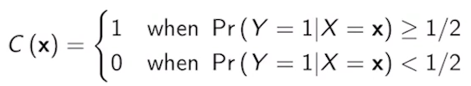
這種「過半就判 1」的做法，唯一的優點是能讓總錯誤人數最少。但正如影片所說：
- 醫生角度：漏診癌症（偽陰性，FN）會害死人；誤診癌症（偽陽性，FP）只需要再做一次檢查。FN 的代價遠大於 FP。
- 銀行角度：把錢借給一個會倒債的人（FN），銀行直接慘賠本金；拒絕一個好人的貸款（FP），銀行只是少賺利息。FN 的代價同樣遠大於 FP。

為了保護銀行或醫生，我們引入一個可自由調整的分類門檻 τ。只要「機率 > τ 我們就判斷為 1。
- 如果我們想採取極度嚴格的風控（寧可錯殺，不可放過），我們就把 τ 從 0.5 往下降（例如設為 0.2）。
- 這樣一來，只要客戶有一點點違約的嫌疑（機率達 20%），銀行就不借他錢。這會讓偽陰性率（漏網之魚）大幅下降，但代價是偽陽性率（冤枉好人）會隨之上升。
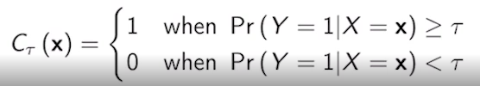

2. 門檻 τ 從 0 到 1 的極端演變
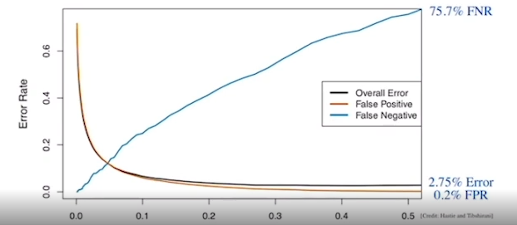
影片精準地描述了當 τ 移動時，兩種錯誤率的對抗關係：
- 當 τ = 0 時：
任何人的違約機率都一定 > 0。因此，模型把所有人都判為 1（全部不給貸款）。
  - 結果：壞人全部被抓到，所以偽陰性率（FNR）變成了 0（藍線起點）。
  - 代價：好人也全被當成壞人，所以偽陽性率（FPR）飆到 1.0 (100%)（橘線起點）。
- 當 τ = 0.5 時（貝氏平衡點）：
這就是我們上一段算出的數據：總錯誤率 2.75%、FPR 是極低的 0.2%（幾乎不冤枉好人），但 FNR 卻高達 75%（放過了大批壞人）。
- 當 τ 漸漸變大：
模型變得越來越難判 1，於是藍線（FNR）單調遞增，橘線（FPR）單調遞減。

3. 分類器的終極試金石：ROC 曲線與 AUC
為了把這場「門檻變動遊戲」視覺化，科學家發明了 ROC 曲線（Receiver Operating Characteristic curve）。
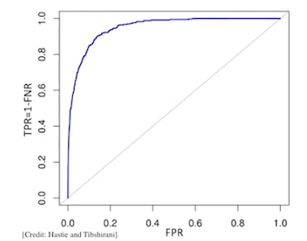
ROC 曲線的坐標軸定義：
- 橫軸（X軸）：偽陽性率（FPR，冤枉好人的機率）
- 縱軸（Y軸）：真陽性率（TPR，抓到壞人的機率，也就是 1 - FNR}）
曲線上的三個聖地：
- 右上限 (1, 1)：對應 τ = 0。所有人都是 1。抓到所有壞人（TPR=1），但也冤枉所有好人（FPR=1）。
- 左下限 (0, 0)：對應 τ = 1（虛無分類器）。所有人都是 0。沒冤枉好人（FPR=0），但也沒抓到半個壞人（TPR=0）。
- 貝氏最佳點：大約落在 (0.002, 0.25) 附近。雖然 FPR 只有 0.2%，但 TPR 也只有 25%，在圖上這是一個靠近左下角的點，對銀行來說很不划算。如果銀行想把 TPR 拉高到 80%，就必須沿著曲線往右上方走，調低 τ，同時忍受變高的 FPR。
什麼是 AUC (Area Under Curve)？
ROC 曲線底下的總面積就叫 AUC，數值介於 0.5 到 1 之間：
- 盲猜硬幣模型（AUC = 0.5）：如果你純靠丟硬幣（正面判 1、反面判 0）來決定要不要貸款，調整過關機率後，你的 ROC 會是一條對角斜線，面積剛好是 0.5。
- 完美模型（AUC = 1.0）：一個完美的分類器會直奔左上角 (0, 1) 聖地（不冤枉任何人，且抓到所有壞人）。這時曲線會變成一個正方形，面積為 1。
- LDA 模型：影片中 LDA 算出來的曲線高高拱起，遠高於對角線，代表這個模型家族的本質分類能力是非常優秀的，只是之前 τ=0.5 的落點不符合銀行利益而已。
💡 課程全系列完結核心回顧
- 邏輯斯迴歸 vs. LDA：一個直接猜機率，一個假設數據符合常態分佈。
- 線性特質：LDA 因為假設各類方差相等，所以取 Log 後的決策防線是直的。
- 數據估計：大自然的參數不可得，我們用樣本平均數和自由度（N-K）來猜。
- 指標照妖鏡：別被總準確率騙了，要看混淆矩陣的 TPR 和 FPR。
- ROC 與 AUC：透過變更 τ，我們能畫出 ROC 曲線，而 AUC 則是評估這個模型到底是不是「垃圾」的終極指標。

3. Python Lab
▶️ Python Lab: Confusion matrix and LDA (12:10)
Hello everybody, welcome to recitation four, part 2. Last time, we looked at logistic regression, hypothesis testing and multiple logistic regression. This time we'll be looking at confusion matrices, linear discriminant analysis, and receiver operating characteristics.
So as a reminder, the Smarket dataset contains 1,250 rows, where each row is a date with information about the S&P 500 stock index. So information is recorded in the columns Lag1 through Lag5, which is the percentage returns for each of the previous trading days, Volume, which is the number of shares traded on the previous day in billions. Today, which is the percentage return of the date in question, and Direction, which is whether the market goes up or down on this date. Looking at our imported libraries, we'll be using linear discriminate analysis, confusion matrix, and classification report in this recitation.
So last time we made predictions with the Smarket data using logistic regression, now you're going to explore the Confusion Matrix for this learn model. To do this, we create a data frame of predictions where each element is 1, if our model predicts a probability of going up greater than 0.5, and a 0 otherwise. Now, by definition a confusion matrix C, is such that c i comma j, is equal to the number of observations known to be in group i, or predicted to be in group j. Therefore, in binary classification, the count of true negatives is C0 0, which is 145, the Count of false negatives is C1 0 which is 141. The false positive count is the first row, second column here 457, and the true positive count is the second row, second column.
We can also compute the accuracy score with accuracy score imported from SKLearn and dot metrics. This function takes in two vectors of categorical data and computes the proportion of rows that match over all rows.
Note that the diagonal elements of the confusion matrix indicate correct predictions, and the off-diagonal elements represent incorrect predictions. So our model correctly predicted that the market would go up on 507 of the 1,250 days, and correctly predicted that it would go down on 145, of the 1,250 days. So this is a total of 652 correct predictions divided by 1,250 total days gives us a 52.2% accuracy. So at first glance, it seems that this is a little better than random guessing, which we would expect would result in a 50% accuracy. But note that this is overly optimistic, because this is computed on training data.
So here's a not so good way to split your training and test sets, we will explore a much better method when we cover cross validation in the next couple recitations. The reason is that we want our training data and test data to be as similar as possible. So normally, we would randomly split them into test and training data. However, for this example, this method will suffice because we expect that data after the year of 2005, will not differ too much from data before the year of 2005. So now we fit a new model called fit two, where the data we pass in is data train.
We see that in the summary, none of the coefficients can reject the null hypothesis with 95% confidence, and this is expected of stock market data.
Now we define two new vectors xtest, and ytest. Xtest is taken from the second column to the second to last column, and ytest is taken as the very last column. Now we can obtain a vector of probabilities from the xtest, this can be done by calling fit2.predict and passing an xtest. So to reiterate, yprobs is a vector where each row is the probability that its corresponding date and xtest, will go up. We can then define a vector ypred, which is 0, the probability of going up is less than 0.5 and 1 otherwise. Now we construct the confusion matrix of ytest and ypred, we see that the accuracy score is 48%, which is worse than random guessing.
Let's try to improve our error rate by removing the least correlated variables. These are the variables, whose coefficients have the highest p values equivalently, the lowest absolute value of z statistics. So now we fit a model or direction, the function of lag1 and lag2, we obtained an accuracy score of 56%, which seems better than our previous model. However, if you look at the second row in our confusion matrix, which are all the times the stock did in fact, go up, then, and we divide by the total number of test instances, you see that a went up to 56% of the time. This means that our model does no better than predicting the stock will go up for every test instance. However, if we look at the second column, which is all the times that our model predicted that a stock will go up, when only considering these instances where the model predicts that it will go up, it is correct 58% of the time which is 106 divided by 106 plus 76. This suggests a possible trading strategy of buying on days when the model predicts an increasing market, and avoiding trades on days when a decrease is predicted. However, we would definitely need to investigate more carefully if this is an actual improvement, or was just due to random chance.
Now we go over how to perform linear discriminant analysis, first we define an LDA model as seen in the first line of cell 19. Then we define an x train vector, which is the columns index from 1 to 3, and data train, and xtest vectors the same columns and data test. The ytrain vector is the last column data train. And then we call our model fit4.fit and we pass in our xtrain and ytrain. We can then obtain a vector of predictions using fit4.predict passing in our xtest. We see the confusion matrix and the accuracy score on the same test data as logistic regression, are pretty much identical.
So once again, we're not going to cover QDA and K nearest neighbors, and we will return to default data, as we did in the last recitation. So just a reminder, the default data has columns of default Yes or No, student Yes or No, balance and income.
So here we see the confusion matrix computed from the predicted values with training data, and the actual default values in the training data. Note that the statistics we usually care about, are the true positive rate, the true negative rate, the false positive rate, and the false negative rate, which can be calculated from the table. Potentially we may care about the positive prediction rate, the negative prediction rate, and the misclassification error. So now that we know how to get our statistics of interest from the confusion matrix, and our data, how can we judge if a given model is good enough? To do this, we calculate the statistics of interest as we sweep through every possible classifier for a given model, to obtain the receiver operating characteristic, and the misclassification error curve. To do this, we vary the threshold that our classifier requires of our models predicted probability of Yes, in order to predict Yes, for the instance. So in the last recitation, we saw majority vote classifier, where the threshold was 0.5, to predict, Yes. Then we saw a more conservative classifier where the threshold was only 0.2 to predict Yes. And then we saw a more lenient classifier, where the threshold was higher than 0.8 to predict Yes. So to calculate our ROC and misclassification error curves, we're going to use the following function. Our function will take in a model test data to compute a confusion matrix from, the start and stop values for the threshold, and the total number of thresholds to explore.
Here, we create an array using np.linspace, that starts at our start value, stops at our stop value that has a total number of num points. Now for each threshold in our classifier array, we obtain our predicted values based on the threshold, to obtain our confusion matrix.
And then we maintain an array of true pause, false pause, and misclassification, all computed from the fusion matrix, and where each element in the array corresponds to these values for one threshold.
Now that we have defined a function to return an array of true positive values, false positive values, and misclassification values for each threshold. We call this function passing in our fit, our training data, or a starting threshold of 1, and ending threshold of 0 and 1,000 total thresholds to be explored, then we plot the results. We can plot our misclassification error by setting the x axis to be our threshold values, here we call the classifier, and our misclassification as the y values. We can compute our area under the curve by using numpy.trapz, this takes in a y vector and an x vector, and performs numerical integration using the trapezoidal rule of y of x.
The Misclassification Error and our ROC plot, as well as the area under the curve, can be seen here. Note that the higher AUC, the better model we have learned.
這段實作課展示了如何用 Python 把我們之前討論的統計理論落實到實際的數據分析中。
程式碼背後的核心邏輯與三個關鍵的「數字陷阱」拆解出來。
陷阱一：Smarket 的全資料預測（過度樂觀）
一開始，助教用全資料（1,250 天）進行訓練與預測，得到了 52.2% 的準確率。
- 數學算式：[145(TN) + 507(TP)]/1250 = 52.2%
- 觀念警訊：這叫 Training Error Rate。因為模型已經看過考試題目了，所以算出來的準確率會過度樂觀（Overly Optimistic）。
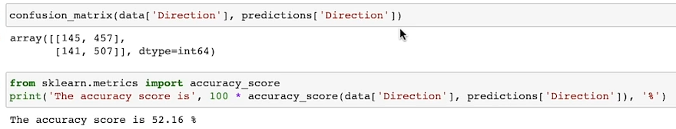

陷阱二：邏輯斯迴歸 vs. 股市的隨機漫步
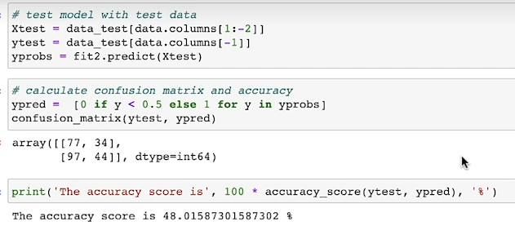
Note: data.columns[1:-2] 是說從column 1抓到倒數第3 column, 左閉右開原則
Note: data.columns[-1]：直接鎖定倒數第一個位置，抓出來的欄位名稱就是 'Direction'
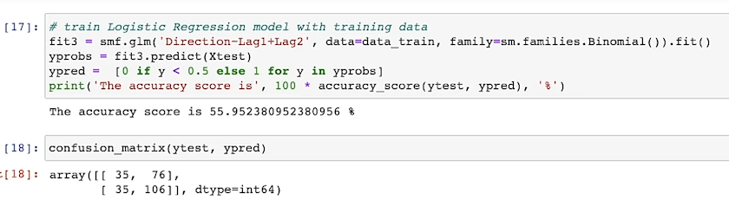
當助教把資料以 2005 年 為界，前面當訓練集、後面當測試集後，事情變得有趣了：
- 全變數模型：測試集準確率跌到 48%（比閉著眼睛瞎猜還爛）。
- 精簡版模型（只留 Lag1, Lag2）：測試集準確率提升到 56%。
56% 的殘酷真相
助教點出了一個極其重要的機器學習觀念：如果我們去看測試集中市場實際上真正上漲的比例，剛好也是 56%。
這意味著，這個精簡版模型其實沒學到什麼高端的預測能力，它只是採取了「永遠預測市場會漲」的無腦策略（Null Classifier），進而輕鬆刷出 56% 的準確率。
- 唯一的交易一線生機：如果唯獨去看「模型開口預測會漲的日子」（Confusion Matrix 的第二欄），它的正確率是 106/(106+76) = 58%。這暗示了一個可能的交易策略（當預測上漲時買入，預測下跌時觀望），但仍需要嚴格的檢驗以排除隨機嫌疑。
陷阱三：用 np.linspace 實作門檻滑動（ROC 的誕生）
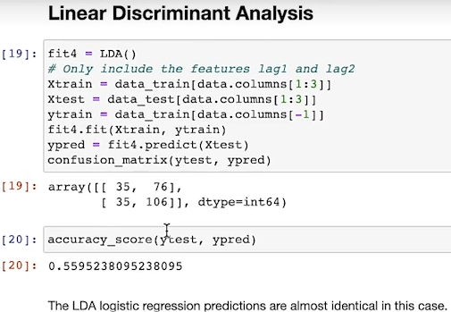
在後半段的 Default 資料集中，助教寫了一個非常漂亮的自動化函式，用來動態尋找最佳門檻。這段程式碼的底層邏輯可以用下面這張流程圖來理解：
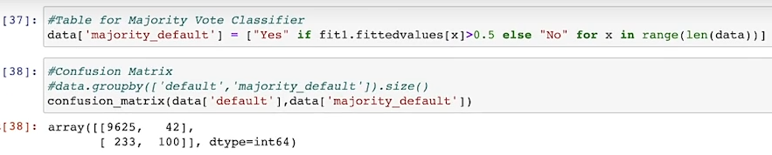
Note: 模型會找出最佳的 $\beta$ 係數（截距與權重）。這時候模型已經建好了，statsmodels 為了方便你做後續的統計診斷，會順手把那 10,000 個原始客戶的數據重新帶入剛剛練好的公式裡，算出每個人對應的預測值，並把它們打包成一個清單存起來。這個清單就叫做 fittedvalues。在邏輯斯迴歸（Logit Model）中，fit1.fittedvalues 算出來的數字，並不是「0到1之間的機率（Probability）」，而是「無邊無界的 Log-Odds（對數勝算）」！
它吐出來的數字其實是線性組合的直接結果：

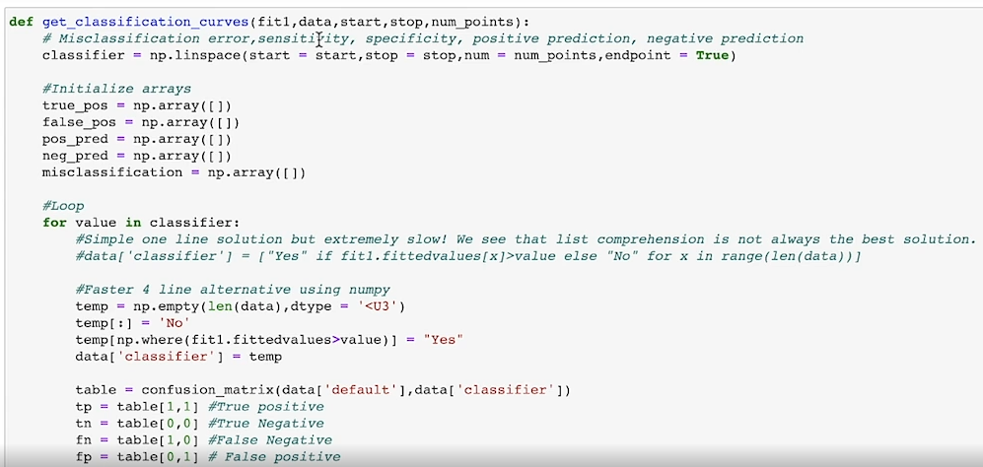

函式實作拆解
助教的自訂函式在後台跑了以下步驟：
- 設定門檻陣列：np.linspace(1, 0, 1000)
這行程式碼建立了一個包含 1,000 個數字的陣列，從 1.0（最嚴格，沒人能借到錢）一路上滑動到 0.0（最寬鬆，每個人都能借到錢）。這個陣列裡面的每一個數字，都會被拿來當作一次信用風險的審核門檻（τ）。
Note: np.linspace(start, stop, num)「固定左端點start，固定右端點stop，然後指定要在這之間均勻切出幾大個刻度點num」
- 跑 1,000 次迴圈：
為什麼原本的寫法會慢？
如果用原本的 Python 列表推導式，每次迴圈都要用 Python 跑 10,000 個客戶，乘上 1,000 次門檻，等於要執行 一千萬次（10^7） 的原生 Python 判斷式，Jupyter Notebook 會直接卡死。
向量化（Vectorization）是怎麼加速的？
助教改用 NumPy 的底層 C 語言矩陣操作：
- 用 temp[:] = 'No' 讓全體一瞬間變成 'No'。
- len(data) —— 決定陣列的「長度」
  - 告訴 NumPy：「我的原始資料集（data）裡有幾個客戶（幾列資料），這個全新挖出來的空陣列就必須恰好有幾個格子。」
- dtype='<U3'—— 限制格子的「資料型態」
  - <（小端序 / Little-Endian）
  - U（Unicode 文字）
  - 3（最大字元長度限制）: "Yes"（3個字母）和 "No"（2個字母）
- 利用 np.where(fit1.fittedvalues > value) 像探照燈一樣，一瞬間鎖定所有衝破當前門檻 value 的高風險客戶，整批直接覆蓋成 'Yes'。
  - 內部條件判定 fit1.fittedvalues > value, NumPy 會對每個人進行布林值（Boolean）問答，產生一個全是對或錯的陣列：
  - 例如輸出：[False, True, False, True, False] （只有編號 1 和 3 的人衝破門
  - np.where 看到上面這串布林陣列後，它只關心 True 出現在哪裡。它會把那些 True 的索引位置（座位號碼）打包吐出來：輸出：(array([1, 3]),)

在資料科學中被稱為向量化操作，是提升效能的必學王道。

在每個門檻（例如 τ= 0.2）下，將模型預測的違約機率進行二元轉換：
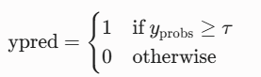

- 抽取指標並記錄：
每次轉換後，立馬計算 confusion_matrix(y_true, y_pred)，從中取出當下的真陽性率（TPR）、偽陽性率（FPR）和整體錯誤率（Misclassification），並塞進陣列記錄下來。
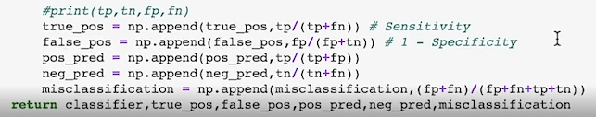
動態畫面還原：陣列是怎麼越長越長的？
當你的 linspace 切了 1,000 個門檻，迴圈在背後跑 1,000 次的時候，以儲存 ROC 橫座標的 false_pos 桶子為例：
- 第 1 次迴圈 (τ = 1.0)：算出來的 FPR 是 0.0, false_pos: [0.0]
- 第 2 次迴圈 (τ = 0.999)：算出來的 FPR 是 0.0001, false_pos: [0.0, 0.0001]
- 第 3 次迴圈 (τ = 0.998)：算出來的 FPR 是 0.0002, false_pos: [0.0, 0.0001, 0.0002]
- ...
- 第 1,000 次迴圈全部跑完：false_pos 桶子裡就妥妥地躺了 1,000 個浮點數，紀錄了門檻從高到低每一刻的 FPR 變化！

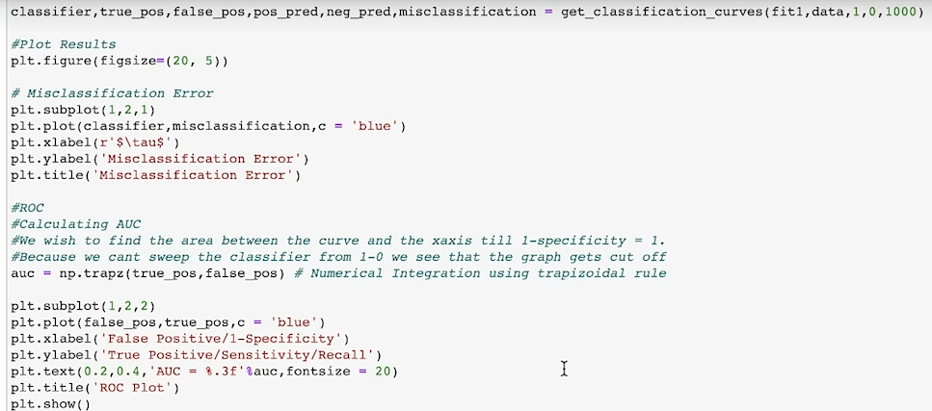
梯形數值積分計算 AUC
有了這 1,000 個點的 TPR（Y軸）與 FPR（X軸）坐標後，助教使用了 Numpy 的內建函數：
auc = np.trapz(y_vector_of_tpr, x_vector_of_fpr)
auc = np.trapz(true_pos, false_pos)
這行指令利用微積分的梯形法（Trapezoidal Rule），把這條拱起的 ROC 曲線下方的面積切成 1,000 個小梯形進行加總。算出來的 AUC 越接近 1.0，就代表這個模型在應對各種風控場景下的綜合體質越優秀。
💡 實戰小結
這段 Recitation 的精髓在於告訴我們：
- 寫程式時，不要只看一個預設的 model.predict()，因為它預設的門檻是 0.5。
- 在實務上（不論是股市操作還是銀行風控），我們必須利用迴圈去滑動門檻，並利用 np.trapz 計算 AUC，才能挑選出真正符合我們風險承受度的最佳分類門檻。

1. Scikit-learn 派系（工程師思維：著重預測未來）
- 代表模型：LinearDiscriminantAnalysis(), LogisticRegression(), RandomForest()
- 語法特徵：永遠是 .fit(X, y) 訓練，然後用 .predict(X_new) 預測。
- 屬性慣例：所有訓練完學到的東西，後面一定帶有底線（如 .coef_, .intercept_）。
- 它沒有 fittedvalues。
2. Statsmodels 派系（統計學家思維：著重解釋過去）
- 代表模型：smf.logit(), smf.ols()
- 語法特徵：習慣用 R 語言風格的公式（例如 "default ~ balance + income"）。
- 屬性慣例：它在設計上就是為了讓你做統計診斷（看殘差、看 p-value 報告）。既然要看報告，它在擬合完的當下，就一定會把訓練集本身的統計量（如 fittedvalues、resid 殘差）直接算好當作內部變數。
💡 核心結論：當你看到助教寫 smf.logit 時，你的大腦就要立刻聯想到「這是統計學家派系的 statsmodels」，接著你就能預期它身上帶著豐富的歷史統計屬性。

